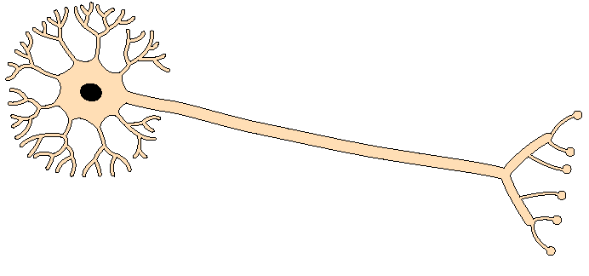 | Nerve cell  (neurone) | Connect sensors to the brain  (animal) | Long length for transmitting signals over long distance
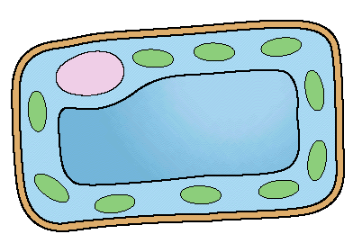 | Palisade cell | Leaf  (plant) | Transparent, regular shaped cells with chloroplasts
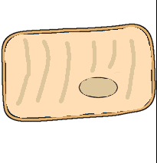 | Muscle cell | In the muscles  (animal) | Can stretch to allow lengthening of muscles
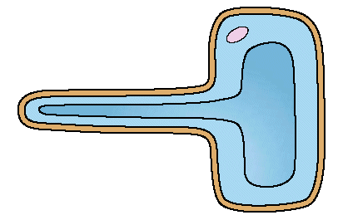 | Root hair cell | Plant root  (plant) | Long and thin to increase surface area, take water into up into plant cells
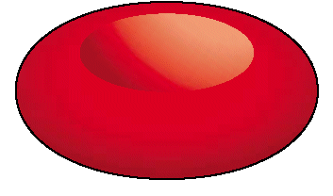 | Red blood cell | Blood  (animal) | Large surface area for absorbing oxygen
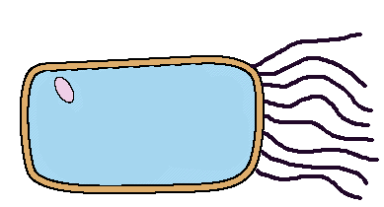 | Ciliated Epithelial cell | Lines cavities  e.g. airways  (animal) | Has tiny hairs to help move liquids
 | Sperm cell | Testes  (animal) | Tail which allows cell to swim
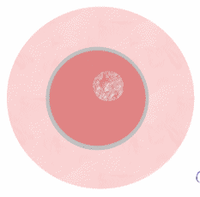 | Egg cell | Ovary  (animals and plants) | Contains large food store and genetic material to grow and develop
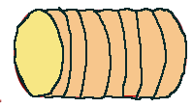 | Xylem cell | Plant stem  (plant) | Hollow to carry water
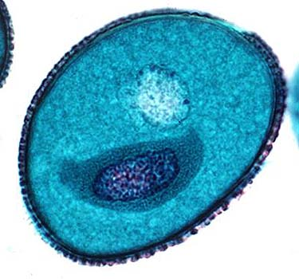 | Pollen cell | Anther  (plant) | Small and light to be easily transferred to the egg cell in the plant

